DECLARATION OF AUTHENTICITY
I ______Zandro Andrew Spinner___________________________________________________________
(FULL NAME)
hereby declare that the contents of this assignment are entirely my own work with the exception of the following
elements: (List the elements of work in this project that were not self-generated as well as who the originator of the element is)
Element | Originator

Signature: _____________________________
Date: __2026/05/08___________

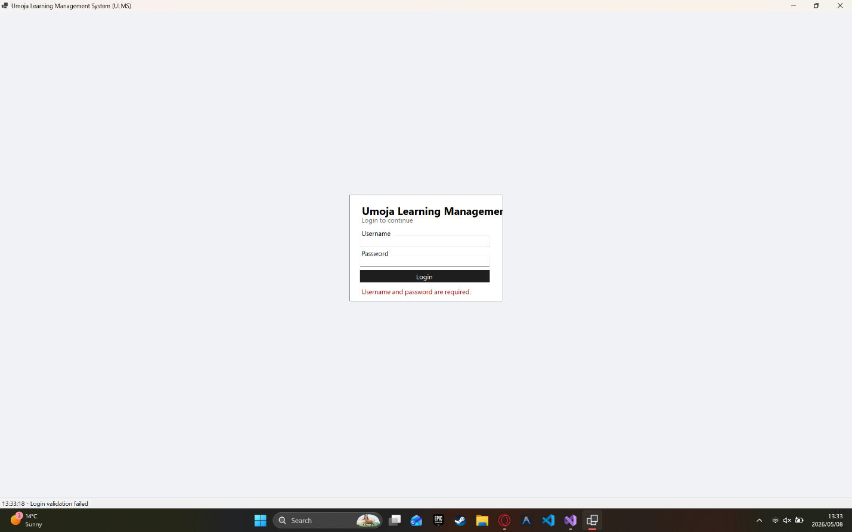

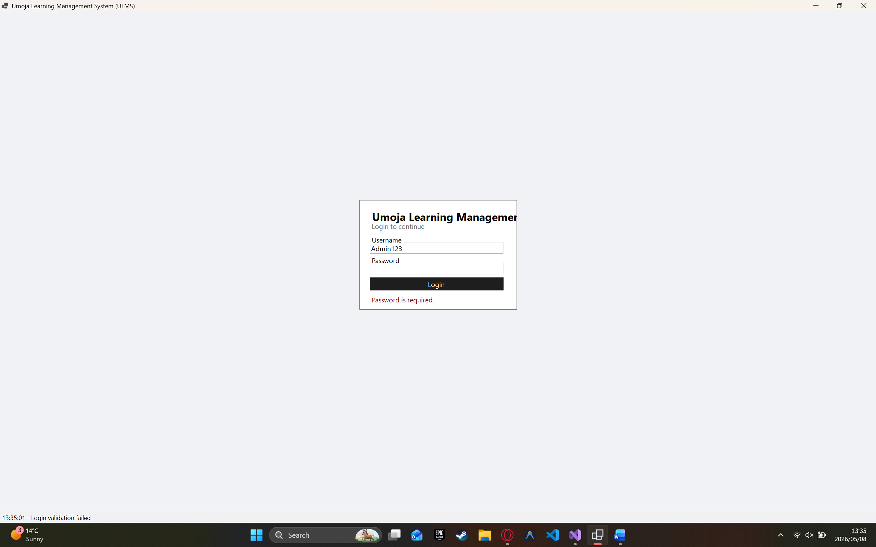
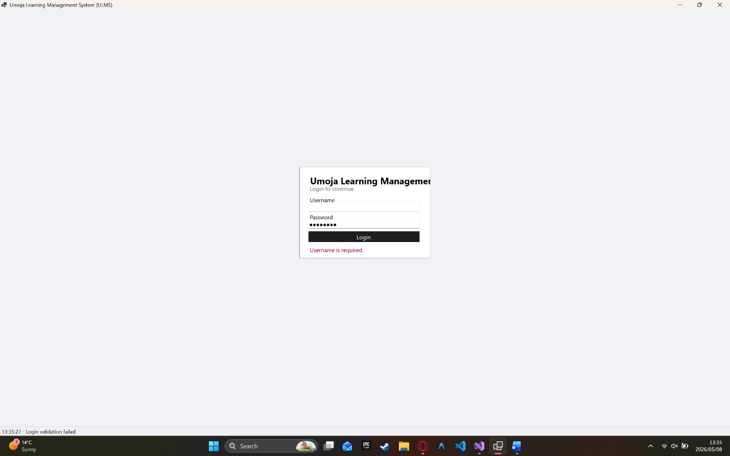
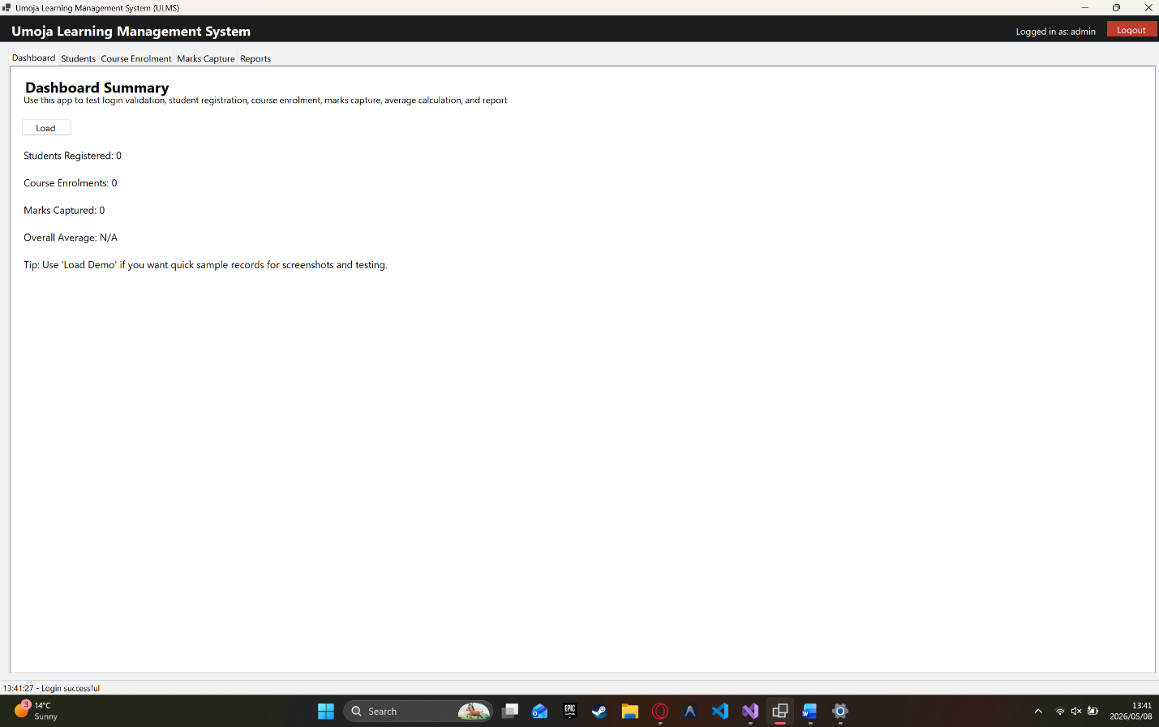
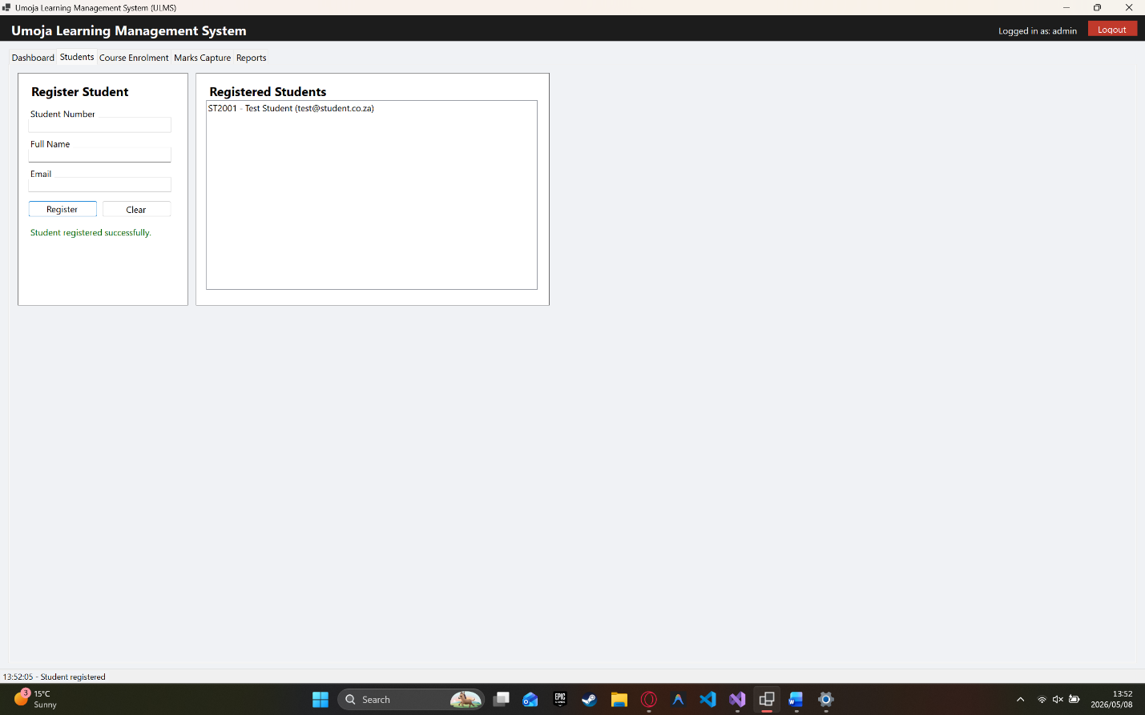
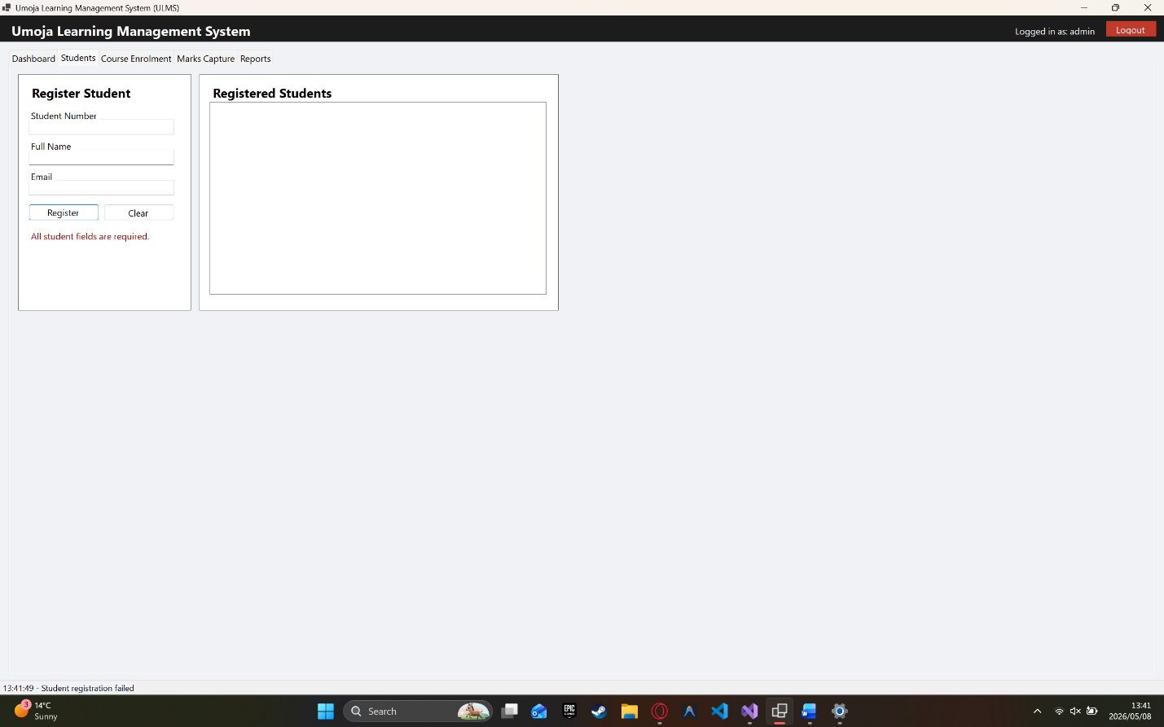

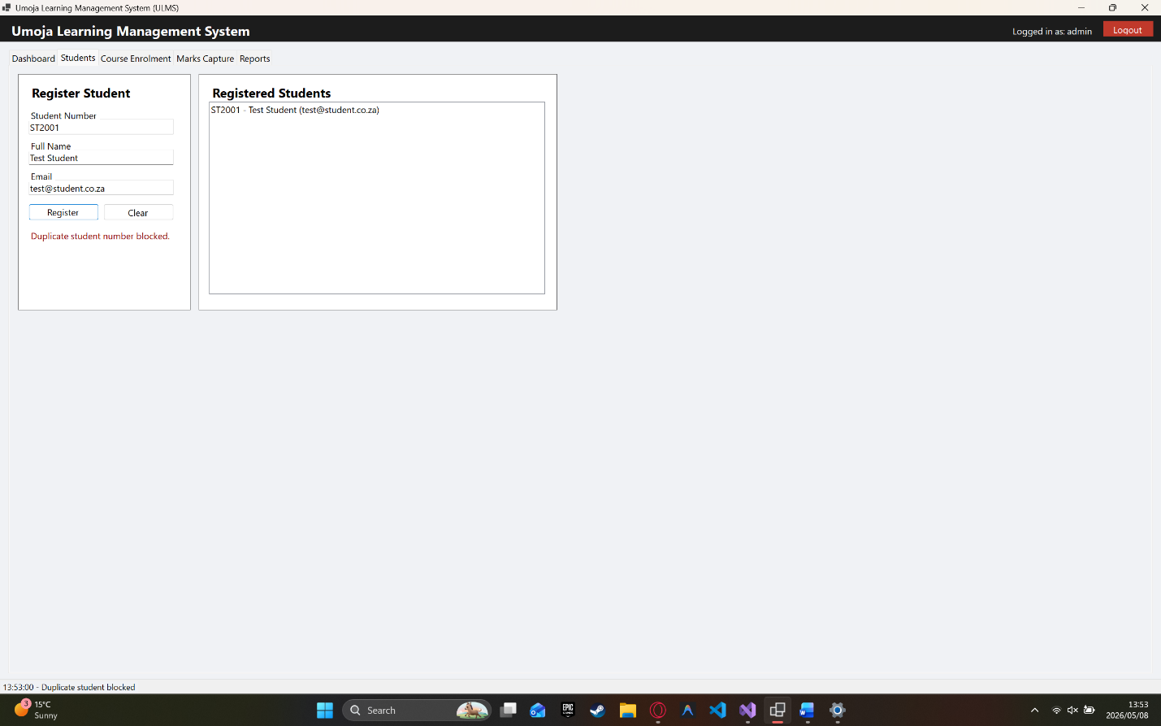
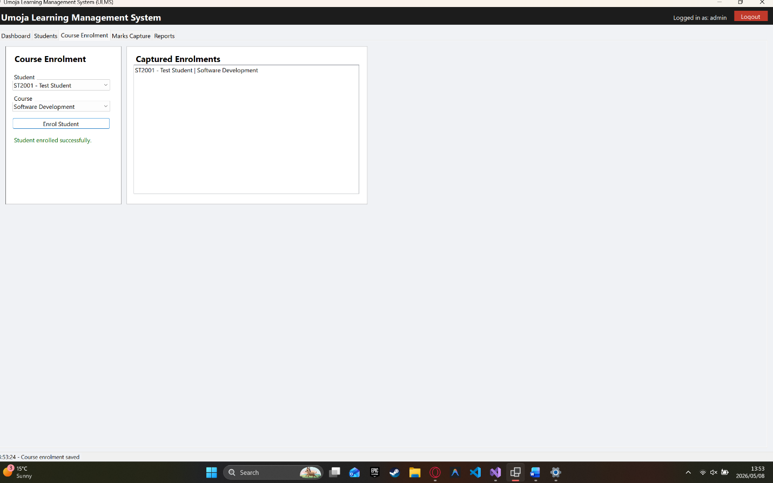
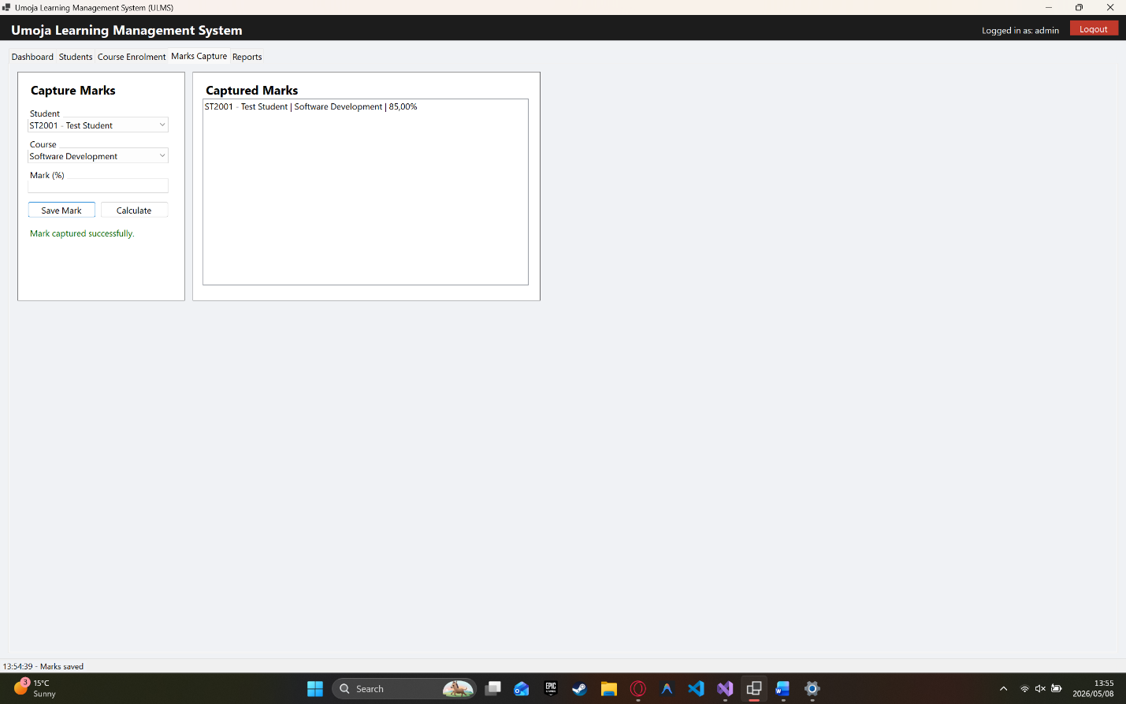
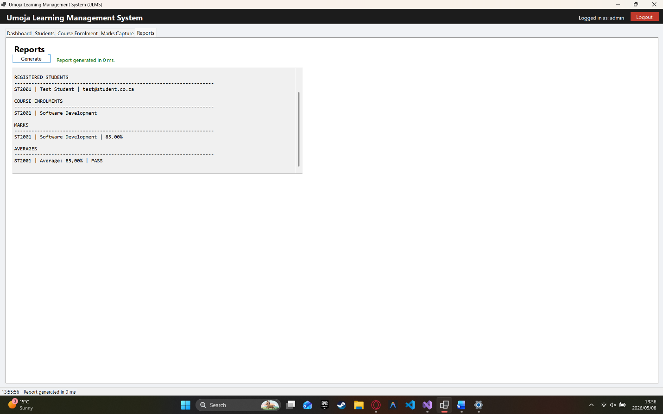
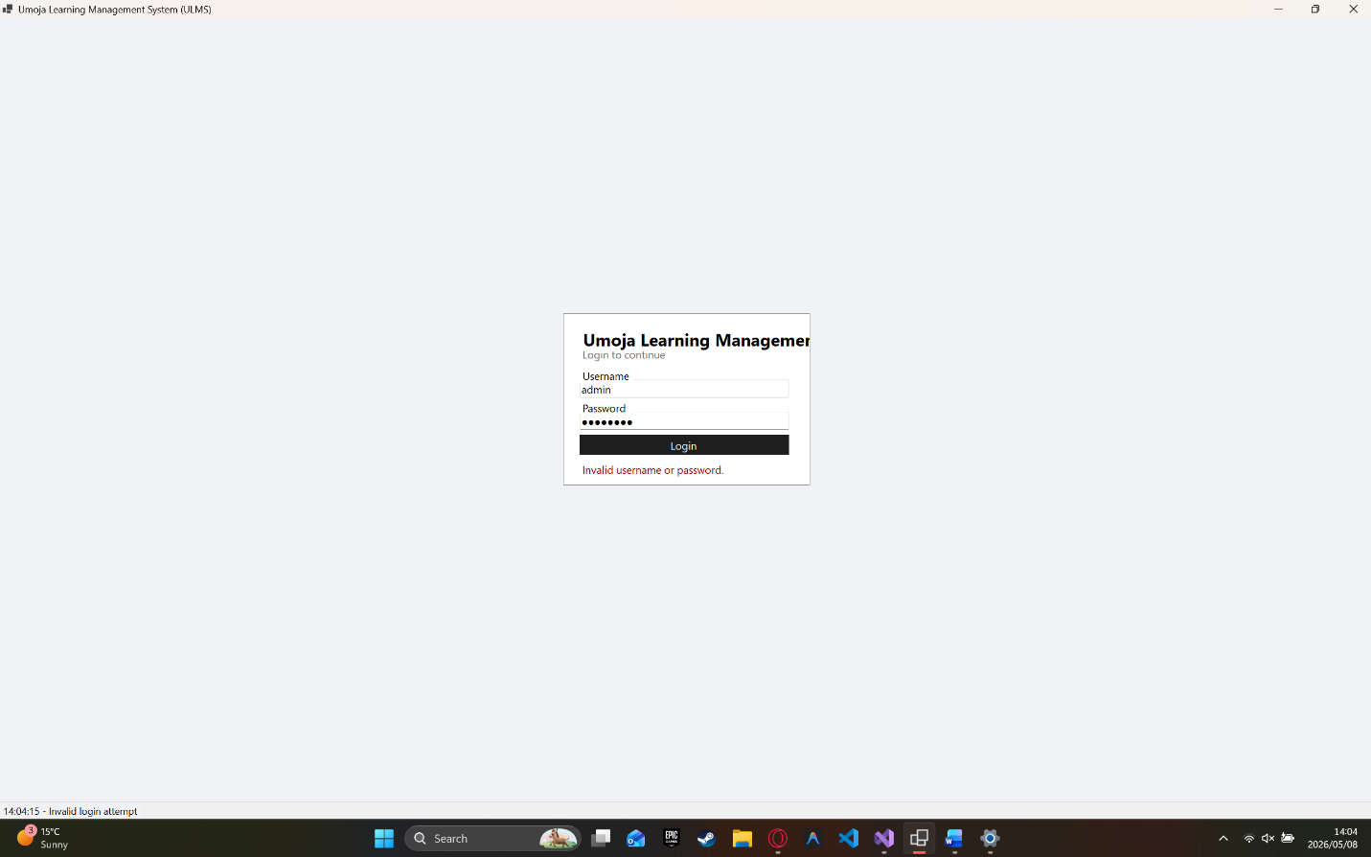
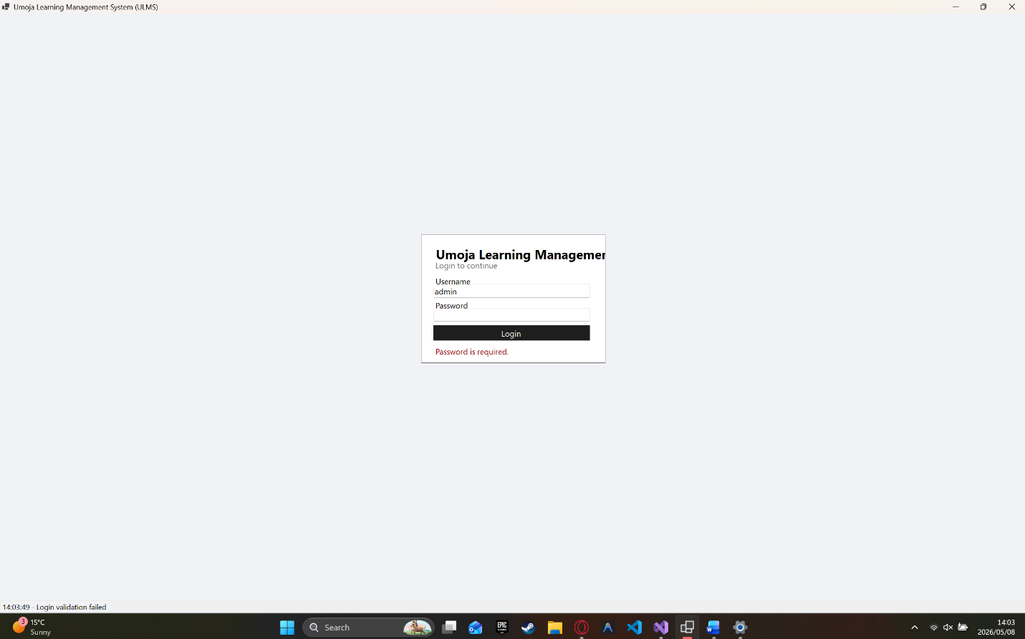
Defects
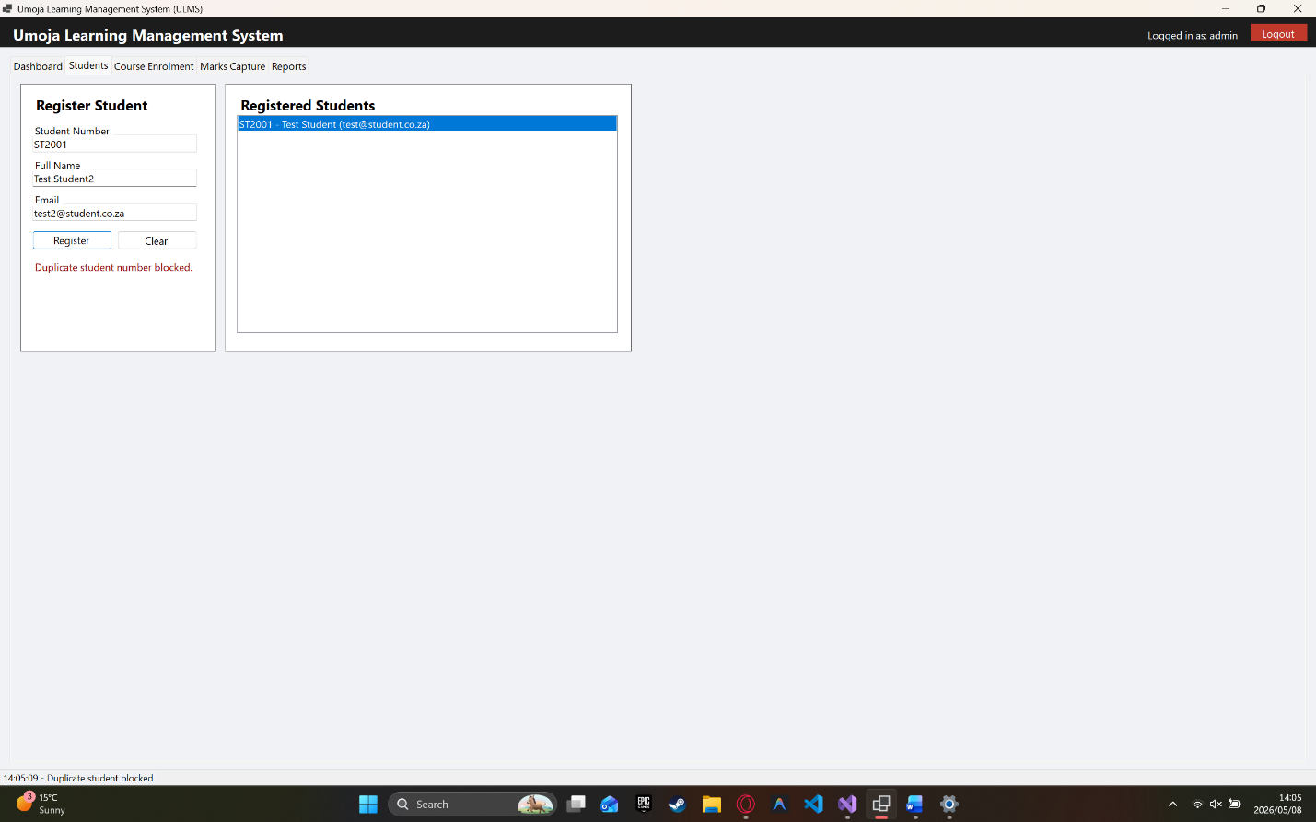
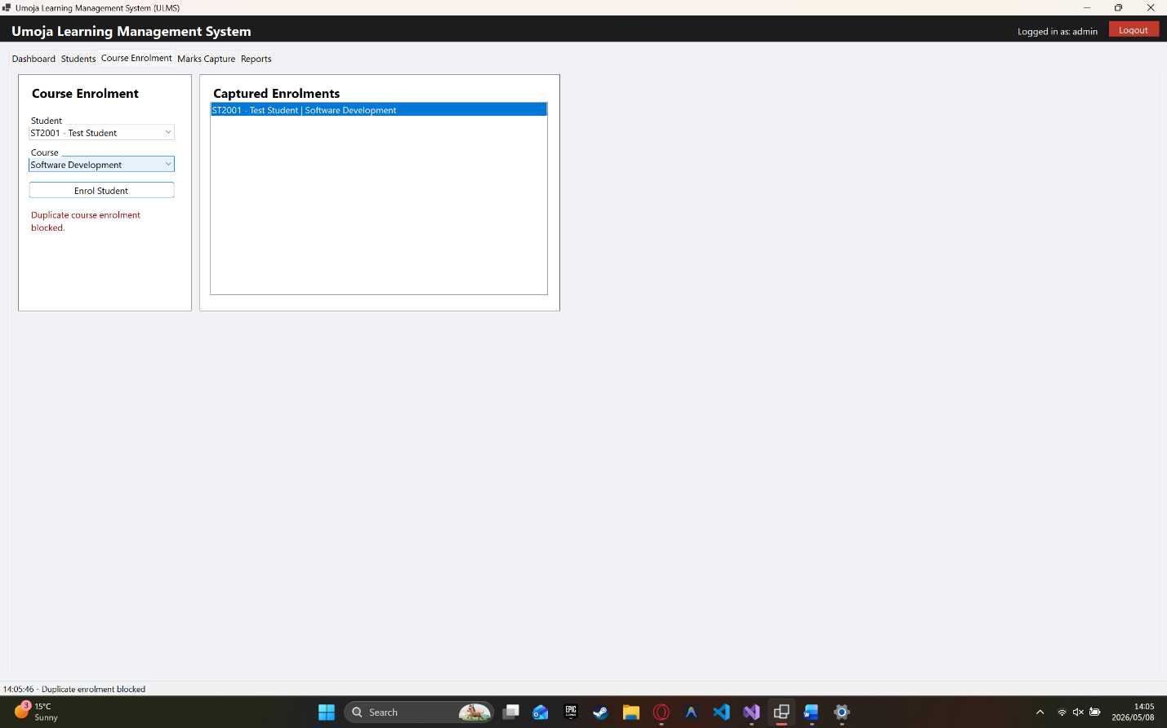
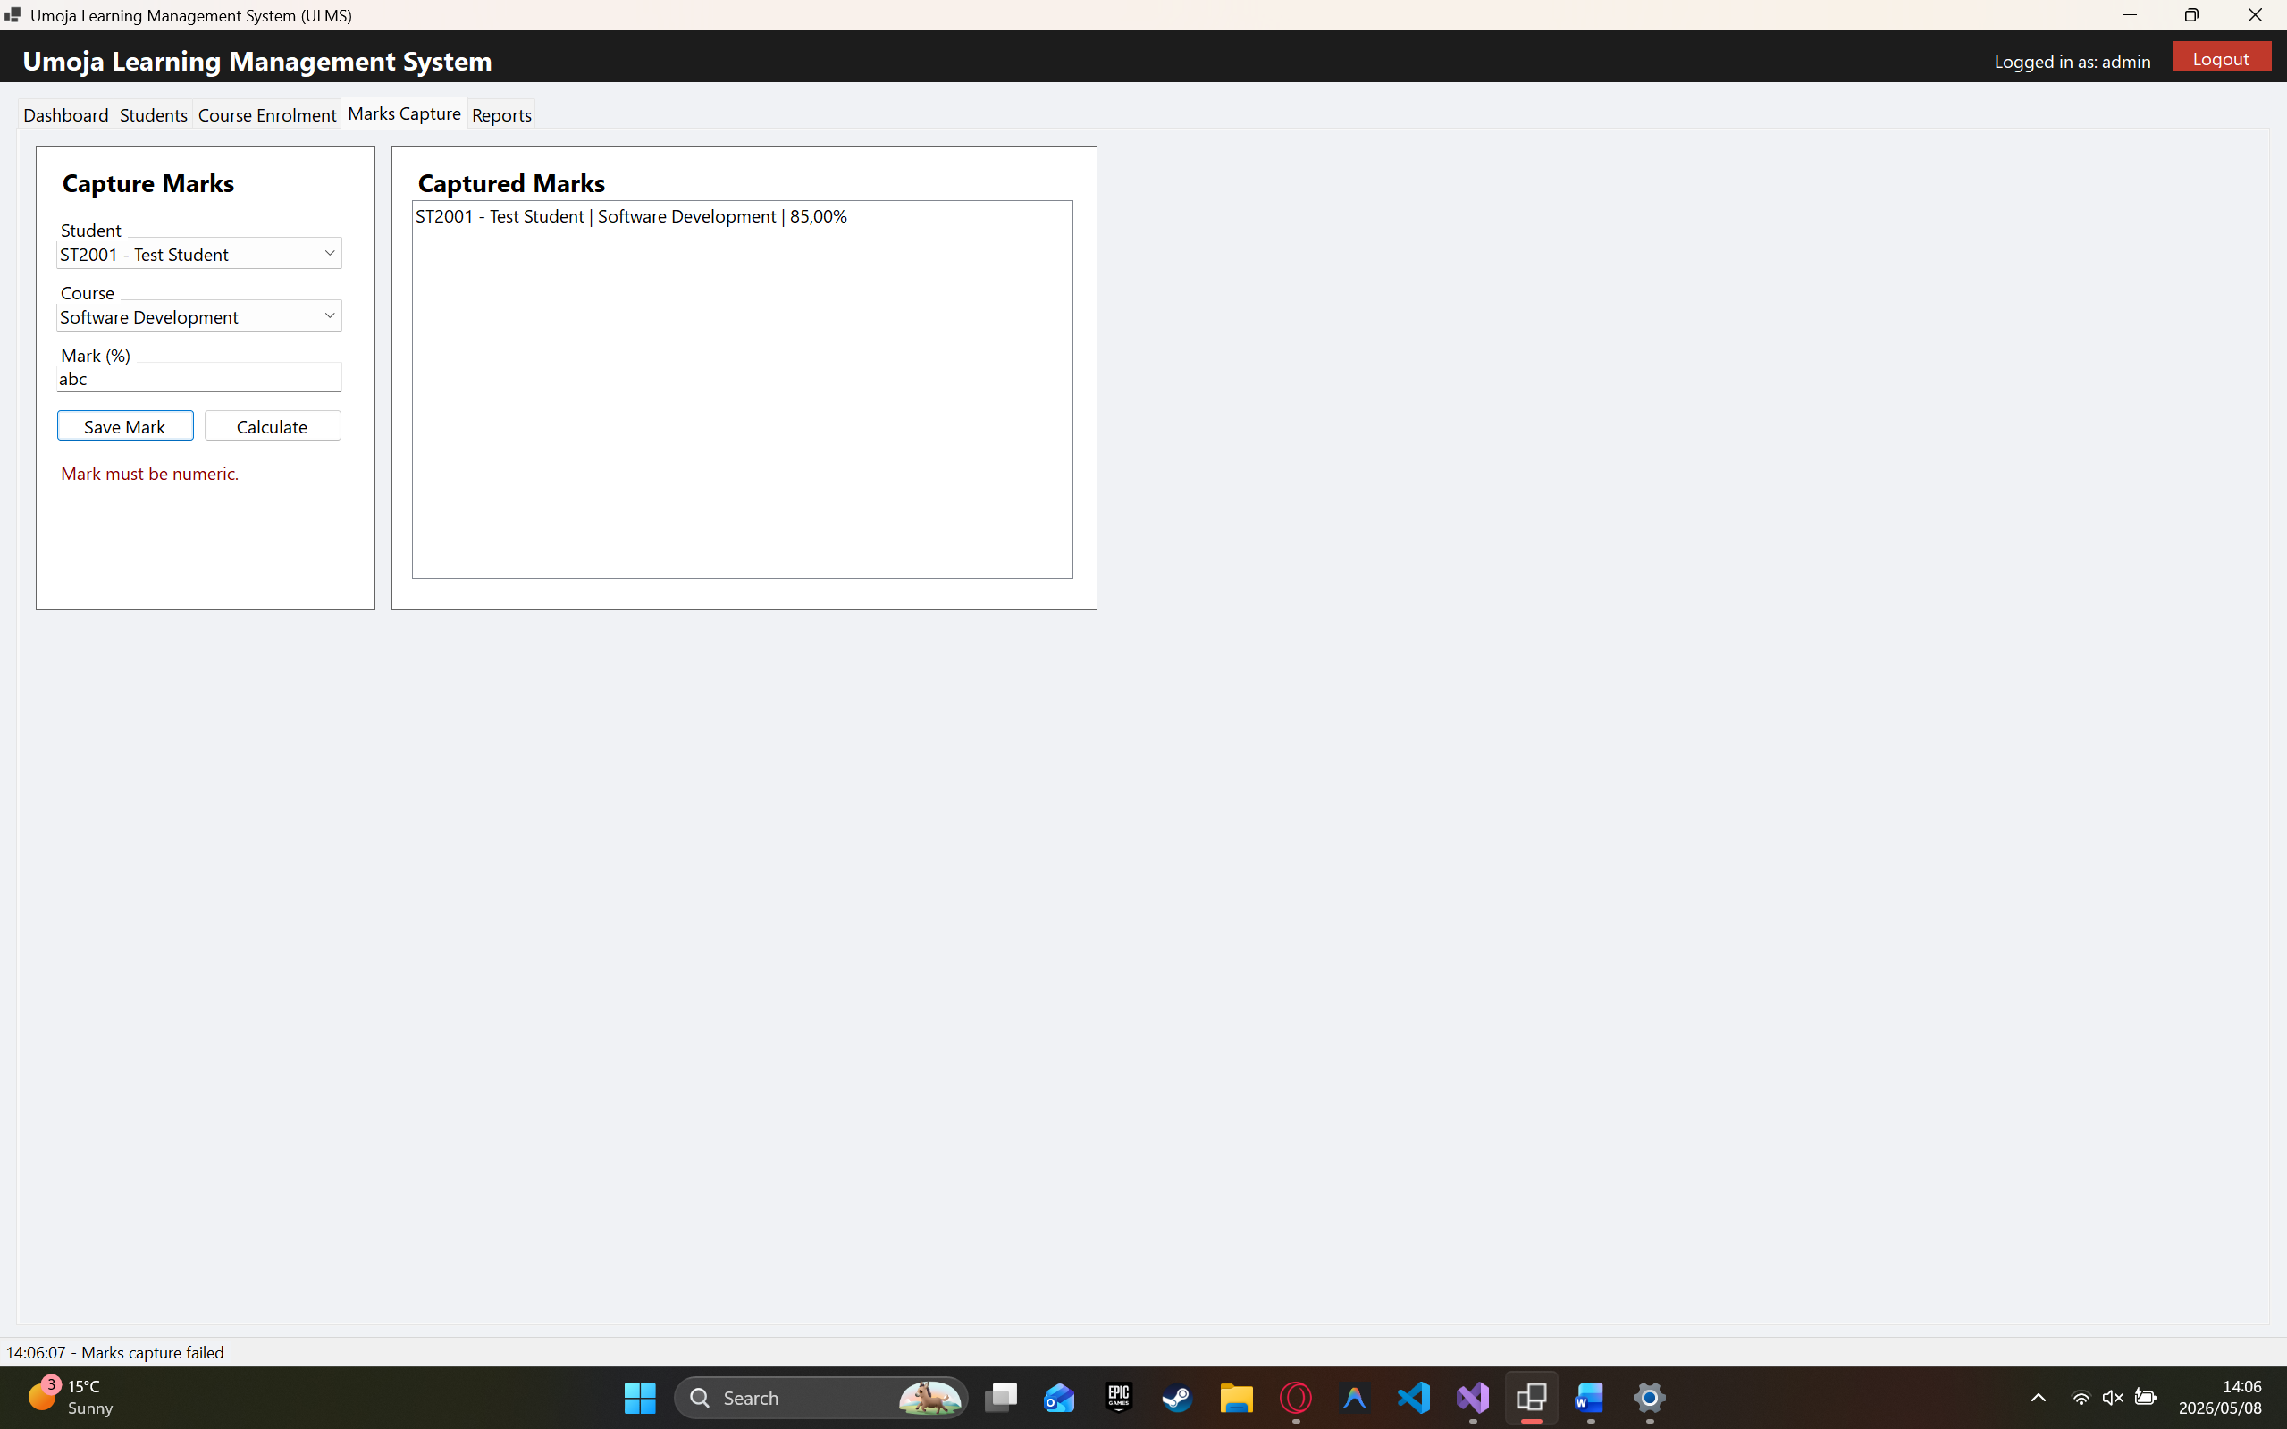

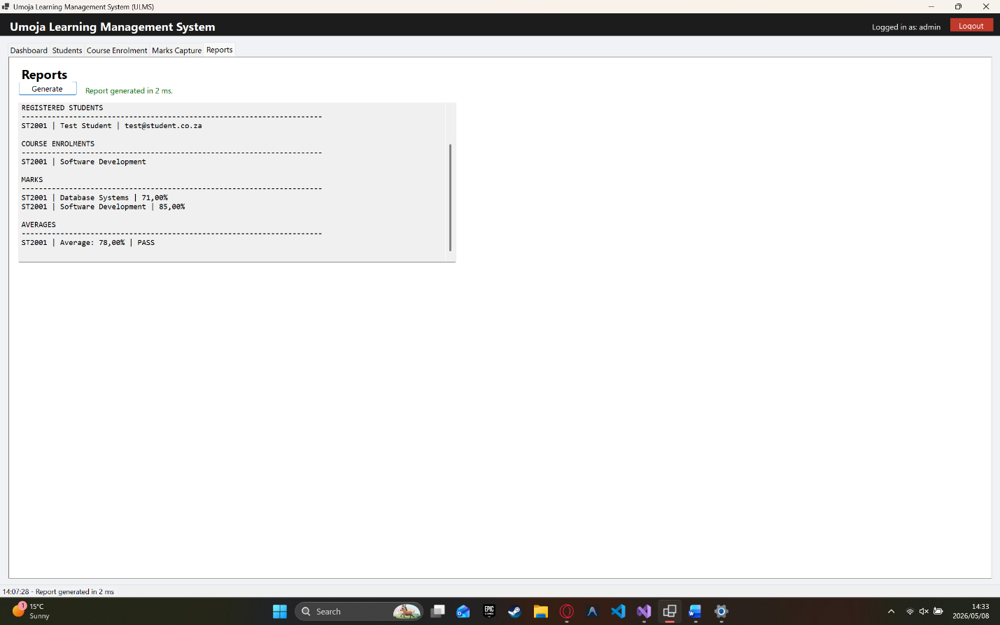
ID | Module | Defect + Corrective Action | Sev/Pri/Status
D01 | Login | Password field could be left empty. Fixed by adding validation to show “Password is required.” | High / High / Fixed
D02 | Login | Invalid login details were not clearly handled. Fixed by adding “Invalid username or password.” message. | High / High / Fixed
D03 | Students | Duplicate student numbers could be saved. Fixed by adding duplicate student-number validation. | Medium / High / Fixed
D04 | Enrolment | Student could enrol in the same course twice. Fixed by blocking duplicate student-course enrolments. | Medium / High / Fixed

D05 | Marks | Invalid marks such as text, negative numbers, or above 100 could be accepted. Fixed by adding numeric and 0–100 range validation. | High / High / Fixed

